STAFFORD
NEWSLETTER 2026

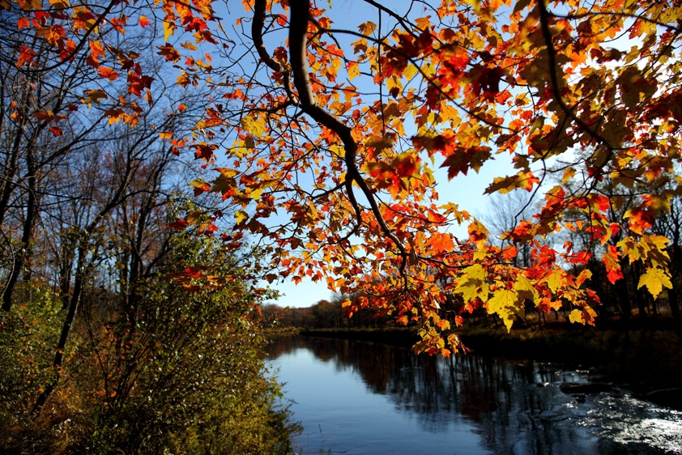
This Photo by Unknown Author is licensed under CC BY

DIRECTORY

Town Supervisor
Robert Clement
Office: (585)344-1554 Ext. 105
supervisor@townofstafford.org
Town Councilman
Robert Pacer Pac3rrob3rt@outlook.com
Terry Young tyoung14143@gmail.com
James Duyssen Jimduyssen@icloud.com
Ronald Panek RndPanek@gmail.com
Assessor
Lori Frongetta
(585) 344-1554 Ext. 106
assessor@townofstafford.org
Highway Superintendent
Steven Boldt
(585) 344-1554 Ext. 201
highway@townofstafford.org
Town Clerk/Tax Collector Registrar
Barbara Radley
(585) 344-1554 Ext. 104
townclerk@townofstafford.org
Deputy Clerk
Jane Scott, Jennifer Lewis
deputyclerk@townofstafford.org
Code & Zoning Enforcement Officer
Gene Sinclair
code@townofstafford.org
Office: (585)344-1554 Ext. 107
Cell (585) 474-1093

Town Justices
Robert Penepent, Robert Mattice Office:
(585)344-4020
Court Clerks
Terry Maid, Marilyn Weinert
(585) 344-4020
Zoning Board of Appeals
Michael Lathan Chair
Crista Boldt
Tim Thomas
Sherry Roberts-Snell
Rob Chapman
Barb Radley Secretary
Planning Board
William VanAlst Chair
Sharon Valyear-Gray
Carol Queal
Lindsay Yoder
Richard Squires
Anita Taylor
Lucas Torrey
Jay Lewis-Alt.
Barb Radley Secretary
Board of Assessment Review
Carol Queal
Dave Kent
John Muehlbauer
Assessor
Lori Frongetta
(585) 344-1554 Ext. 106
assessor@townofstafford.org

Town Historian
Collen O'Connor
(585) 813-2066
From the Desk of the Supervisor
Another summer has come and gone and what a summer it was. The Town has been a very busy place with so much going on. Our Town Board is busy keeping the Town running smoothly and we are all working very well together to serve our residents well.
Please address all concerns and any issues to the Town Officials ONLY; we greatly appreciate your assistance with this.
From the Town Clerk’s Office
Thank you for all your support this year, Jane, and I really appreciate it. We work very hard for you and the Town Board. I would like to introduce our newest Deputy Clerk, Jennifer Lewis; she will be helping Part-Time in addition to Jane and I. Jennifer is a good fit and very helpful to Jane and I.
We have successfully completed the Tax Season again for the fifth year in a row. This saves approximately $5,000.00 per year as opposed to sending the service to Genesee County.
The Day of Caring/United Way did a fantastic job in May and in August we were able to have a group of volunteers from SUNY Brockport weed for us as well! What a blessing it is to have volunteers to “spruce up” our gardens. A Huge Thank you for all their help.
Again, this Christmas season we will have Christmas Trees available for decoration in Ilette Park. Please keep an eye on the website for the specific dates as I am not sure of them yet. It will be available for Stafford residents; you can decorate them with ornaments and or solar or battery-operated lights ONLY; there is not enough electricity available in the park. It will be on first come, first served basis and a limited number of trees will be available. The taking down of the trees will be early January.
The dog and marriage licenses are up again and we Thank You for your cooperation with this also.
So many duties and we still get it done for you with kindness and efficiency. The organization of our office is ongoing but we are almost there; it is not easy keeping up with the changing rules of government but Jane and I are a good team and with the addition of Jennifer it will be even better!
Thank you again for your support and we wish you a safe fall and winter.

Stafford Historical Society Programs Stafford Town Hall 7:00 PM
October 14, 2026 Rob Thompson will speak on his most recent book "Behold and Blush : The Sullivan Expedition". During the Revolutionary War, General John Sullivan led a military operation against the Iroquois Nation across New York State. He was under orders of George Washington to bring about "the total destruction and devastation of their settlements". Books will be available to purchase.
November 11, 2026 Leslie DeLooze will speak about "Jane Boyer 1834: A Schoolgirl's Sampler Reveals a Life and Time". After discovering cross-stitch samplers in the LeRoy House done by a girl from the Ingram Academy, Leslie wanted to find out more about Jane Boyer and her family.
December 9, 2026. Meeting at St. Mark's in LeRoy 7:00PM Jim DeLooze will speak about the Joy Project, followed by a visit downstairs to enjoy the elaborate displays, The Joy Project elicits
memories of Christmas from long ago and introduces younger people to historic holiday traditions. The display includes windows with scenes similar to Sibley's and other department stores' displays, a one-of-a-kind diorama depicting the old-time radio show "The Cinnamon Bear,11 which first aired in 1937, a very large Christmas village and train display, and the chair used by beloved LeRoy Santa Ange Bell. Of special note are the murals by local artist Lorie Longhany, who has created old-time scenes of shoppers in a small village, farms, and Christmas decorations, and a sign pointing to the North Pole. A new mural she is working on this year will depict the North Pole.

Stafford United Methodist Church
Come visit our small loving church any Sunday at 10:15 with Pastor Eric McHugh (585-532-8412) and Organist Joann Collier for worship and fellowship.
Upcoming and Ongoing Events
Sunday November 15th (11;30-1:30) Our 3rd Annual Christmas Card Signing for our local Veterans. Snacks provided while you sign cards that will be delivered to both the Federal and State VA Nursing Homes in Batavia. Can’t stay? You can take cards with you and return later.
Ongoing: We collect 2027 calendars for the VA residents as well as birthday cards. Drop box located at the back door.
Christmas Eve Service: December 24 at 5pm. An offering for the LeRoy Food Pantry will be taken. Lots of Christmas carols sung as well as ending the service in candlelight in the under an hour service.
Coming next Spring!
High Tea: Invite your friends to have tea, finger sandwiches sweet treats and so much more on a warm Sunday afternoon. (After Easter)
Having an event, party or meeting? Need a location? Dinner? Contact Catherine 409-0800 for pricing and assistance.
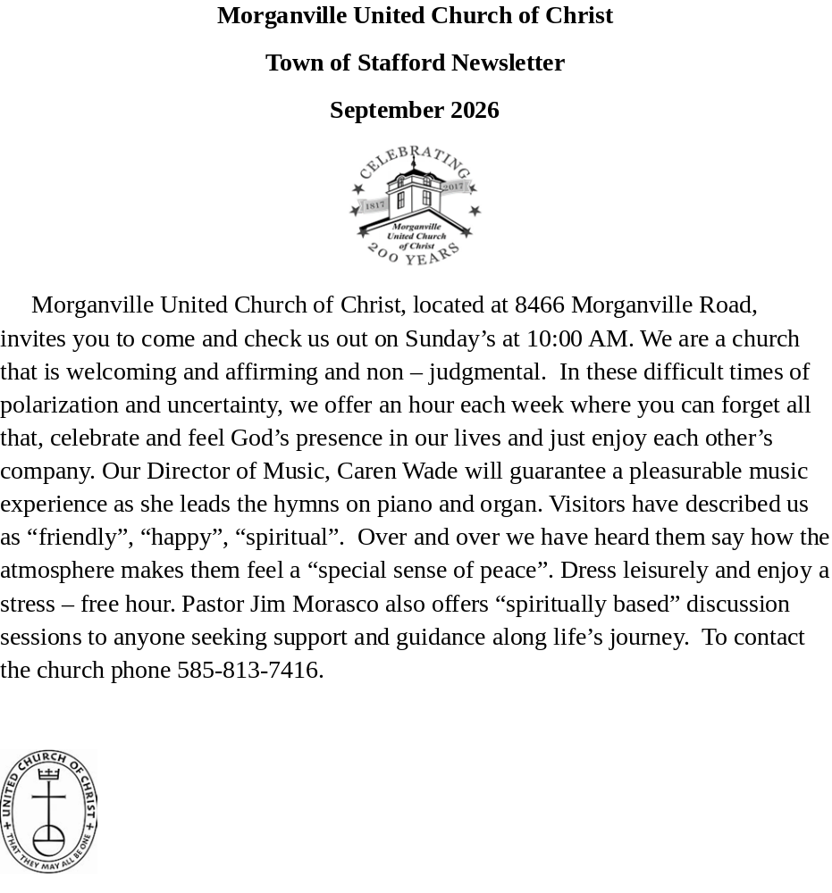

Staﬀord Historical Society Programs Staﬀord Town Hall 7:00 PM
August 12, 2026 Tyler Heiman will speak on the topic “Rails Across The Country; The B&O Across Genesee County”
September 9, 2026 Joyce Thompson Hovey will speak on “The Baker Brothers of Staﬀord”. These were men from Morganville who became prominent during the Civil War and took part in the capture of John Wilkes Booth.
October 14, 2026 Rob Thompson will speak on his most recent book “Behold and Blush : The Sullivan Expedition”. During the Revolutionary War, General John Sullivan led a military operation against the Iroquois Nation across New York State. He was under orders of George Washington to bring about “the total destruction and devastation of their settlements”. Books will be available to purchase.
November 11, 2026 Leslie DeLooze will speak about “Jane Boyer 1834 : A Schoolgirl’s Sampler Reveals a Life and Time”. Jane Boyer's 1834 sampler has been a part of the LeRoy Historical Society since the 1940s. For many years, it hung on the wall, but little was known about it—or even considered. A 2024 project to chart the sampler and to research its beginnings started telling a lengthy story about this LeRoy schoolgirl, early education, her family and her times.
December 9, 2026. Meeting at St. Mark’s in LeRoy 7:00PM Jim DeLooze will speak about the Joy Project, followed by a visit downstairs to enjoy the elaborate displays, The Joy Project elicits
memories of Christmas from long ago and introduces younger people to historic holiday traditions. The display includes windows with scenes similar to Sibley's and other department stores' displays, a one-of-a-kind diorama depicting the old-time radio show "The Cinnamon Bear," which first aired in 1937, a very large Christmas village and train display, and the chair used by beloved LeRoy Santa Ange Bell. Of special note are the murals by local artist Lorie Longhany, who has created old-time scenes of shoppers in a small village, farms, and Christmas decorations, and a sign pointing to the North Pole. A new mural she is working on this year will depict the North Pole.

STAFFORD PLANNING BOARD
Fall 2026

We would like to welcome the newest member of our Board, Jay Lewis. Jay has been appointed as our Planning Board Alternate. He attends our monthly meetings and is available to sit in for any full-time Planning Board member that is absent from a meeting or abstains from involvement on a particular application before the Board. Having an alternate Board member helps to reduce the chance of not having a quorum of the Board at any given meeting. Welcome, Jay!

As we move into the Fall season, everyone is scurrying around to get those “planned” projects finished up before bad weather hits. Just a reminder that those projects may need to have a zoning permit issued by either the Planning Board or Town Board, in addition to a building permit for actually doing the construction. And while the Planning Board tries to move those applications along quickly, there are steps that must be followed and timelines allowed to insure an appropriate review of each application.

Any development other than a single family or two-family dwelling is required to undergo site plan review, even changes in use of an existing commercial or industrial site. If you are contemplating doing business in the Town, or even just splitting off a parcel of land from your lot, please check with our Zoning Enforcement Officer to make sure you follow the proper procedures and obtain proper approvals ahead of time!

Planning Board meetings are held on the 4th Wednesday of the month @ 7:00 PM, except for November and December, when we meet on the third (3rd) Wednesday to avoid Holiday conflicts. Our meeting schedule is posted at the Town Hall, and our monthly meeting agenda is posted on the Town website several days ahead of the meeting. Cutoff dates for getting an item on the agenda are normally eight (8) days prior to the meeting, and applications should be processed through the Zoning Enforcement Officer. Please check at the Town Hall or with the ZEO to confirm meeting dates, as they may be cancelled due to bad weather or lack of agenda items.

Betterment Committee of Stafford NY
Year one in the books and what a year it was. As with any newly formed group, we had ups and downs and a few hiccups…but we made it, now on to 2027.
We could not of done all we did without the help and support of some key residents and businesses, and we would like to thank them all here. Scofield Transfer & Recycling, Shells Post, Batavia Country Club, Stafford Painting, Little Treat Bakery, Stafford Country Club, Casper Farms, St. Paul's Episcopal Church, Red Osier Restaurant, Select Collision, Travel with Cathy, Morganville United Church of Christ (Rick and Gretchen Branton), Breaded Goat Landscaping, Oatka Family Medical, and Wants and Kneads Bakery. A BIG SHOUT OUT THANK YOU!!!
The Betterment Committee of Stafford NY is a volunteer group dedicated to bringing our community together through events and projects. The committee currently has five board members and 15 active members who share a commitment to strengthening community pride and connection in our town. We meet the first Monday of the Month at 5:30pm in the St. Paul’s Parish Hall. Please follow us on our Facebook page Betterment Committee of Stafford NY. All are welcome to come to meetings and share ideas, no commitments, volunteer when you can for what interests you.
The committee is currently working on the following projects and events to complete our 2026 year:
Sunday, October 11 Fall Decorating for the 3 Welcome to Stafford Signs, times to be announced.
Saturday, October 17th from 1-3pm Family Fun “Paint the Pumpkins” at Morganville United Church of Christ Euchre Tournaments ($) will be Saturdays Nov. 14 & Dec. 12 from 3pm – 6pm St. Paul’s Parish Hall (cash prizes)
For a questions, to volunteer or sign up for an event you can email: bcofstaffordny@gmail.com or Call Linda at (585)-344-1056 or Cathy at (716)-308-7885
Should you want to do a donation, those can be mailed to the Betterment Committee at P O Box 113, Stafford NY 14143
2027 Events will see the return of: Continuation of Euchre January through March, Music in the Park, Junk in the Trunk Community Garage Sale, Volunteering at the County Fair Chuckwagon Food Stand, Welcome Sign seasonal decoration and more as we forge ahead. Our 501c3 application is in the process stage and we hope expand our events.
Consider joining us as we cannot do it without volunteers.

Betterment Committee of Stafford NY * P. O. Box 113 * Stafford, NY 14143

