TOWN OF STAFFORD
Est. March 24, 1820

P.O. BOX 52

ROBERT S. CLEMENT
Supervisor
RONALD PANEK
Deputy Supervisor
BARBARA RADLEY
Town Clerk
8903 ROUTE 237

JAMES DUYSSEN ROBERT PACER TERRY YOUNG
Councilmen
STAFFORD, NEW YORK 14143
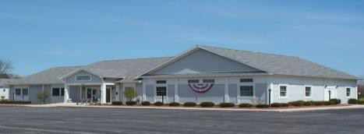
WWW.TOWNOFSTAFFORD.COM
Phone: [585] 344-1554

STEVEN BOLDT
Highway Superintendent

ROBERT MATTICE ROBERT PENEPENT
Town Justice
Fax: [585] 345-0592

LORI FRONGETTA
Assessor

GENE SINCLAIR
Code Enforcement Officer

Stafford Planning Board Meeting Agenda
April 22, 2026 Meeting Time: 7:00 PM

REGULAR MEETING

- Approval of March 25, 2026 Meeting Minutes

- Old Business
  - CDG Genesee 5 and CDG Genesee 6 Solar projects – update on project

- New Business

  - Petition to Amend Town of Stafford Zoning Code from C.E. Crocker, LLC – referral from Stafford Town Board – recommendation for action.

- Correspondence/Workshops/Reports/General Information

- Adjournment

