TOWN OF STAFFORD
Est. March 24, 1820

P.O. BOX 52

ROBERT S. CLEMENT
Supervisor
RONALD PANEK
Deputy Supervisor
BARBARA RADLEY
Town Clerk

8903 ROUTE 237

JAMES DUYSSEN ROBERT PACER TERRY YOUNG
Councilmen

STAFFORD, NEW YORK 14143
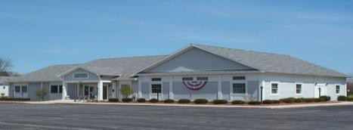
WWW.TOWNOFSTAFFORD.COM

Phone: [585] 344-1554

STEVEN BOLDT
Highway Superintendent

ROBERT MATTICE ROBERT PENEPENT
Town Justice

Fax: [585] 345-0592

LORI FRONGETTA
Assessor

GENE SINCLAIR
Code Enforcement Officer

Stafford Planning Board Meeting Agenda
December 17, 2025 Meeting Time: 7:00 PM

REGULAR MEETING

- Approval of November 19, 2025 Meeting Minutes

- Old Business
  - CDG Genesee 5 and CDG Genesee 6 Solar projects – update on project

- New Business

- Correspondence/Workshops/Reports/General Information

- Adjournment

