The Town Offices will be closed on Thursday, November 27 and Friday, November 28 for the Thanksgiving Holiday. We wish everyone a Happy and Blessed Thanksgiving.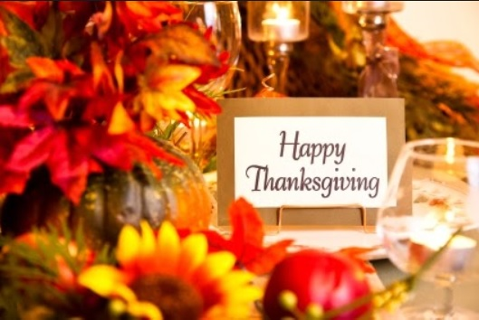
This Photo by Unknown Author is licensed under CC BY-SA-NC

