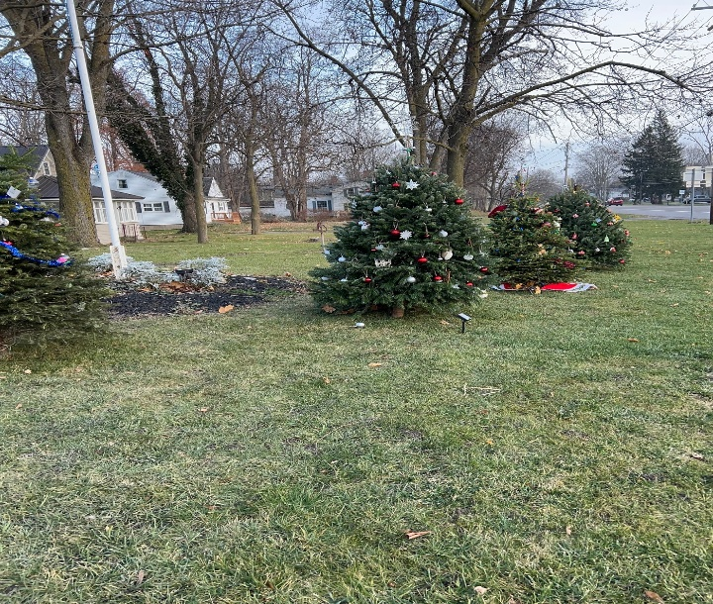

The Second Annual Christmas Tree Decorating will be displayed in Ilette Park again this year. This is for Stafford Residents ONLY.
Please reserve a tree by contacting Barb Radley the Town Clerk at townclerk@townofstafford.org or 585-344-1554 ext. 104 by November 28, 2025.
There are a limited number of trees (15) so please reserve soon. They will be available to decorate the week of December 8, 2025 and please remove all decorations by mid-January. The decorations include ornaments, and lights by solar or battery, no electricity will be provided.

