TOWN OF STAFFORD
Est. March 24, 1820

P.O. BOX 52  ROBERT S. CLEMENT  Supervisor  RONALD PANEK  Deputy Supervisor  BARBARA RADLEY  Town Clerk | 8903 ROUTE 237  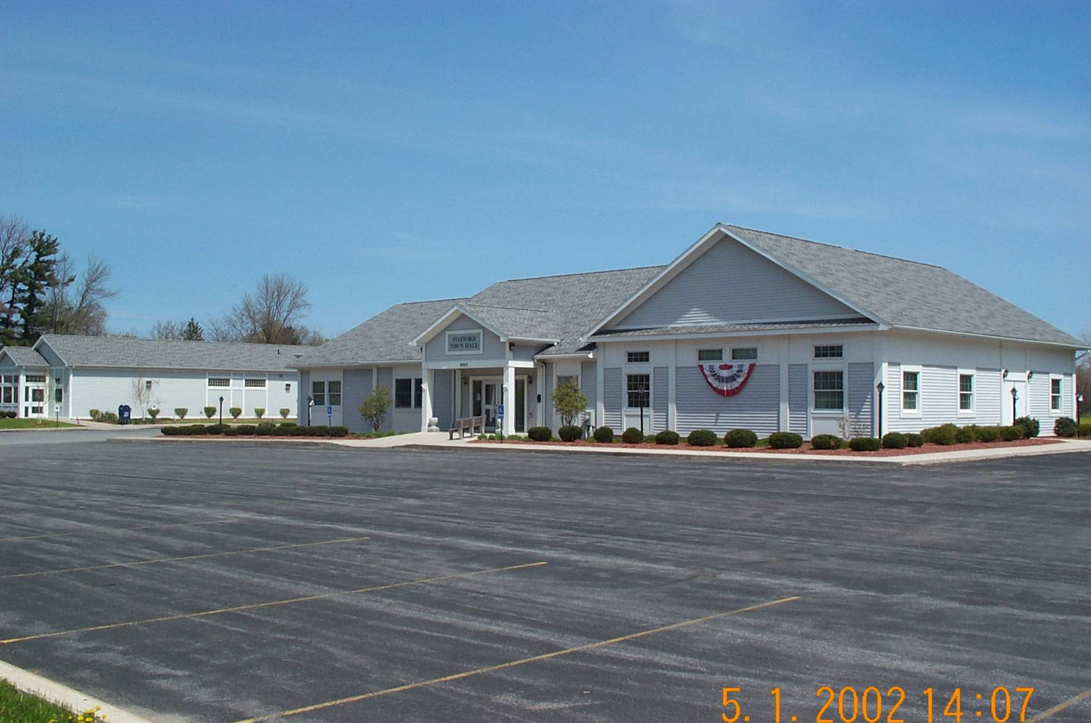  JAMES DUYSSEN  ROBERT PACER  TERRY YOUNG  Councilmen | STAFFORD, NEW YORK 14143  WWW.TOWNOFSTAFFORD.COM | Phone: [585] 344-1554  STEVEN BOLDT  Highway Superintendent  ROBERT MATTICE  ROBERT PENEPENT  Town Justice | Fax: [585] 345-0592  LORI FRONGETTA  Assessor  GENE SINCLAIR  Code Enforcement Officer  Zoning Enforcement Officer

ZONING BOARD OF APPEALS MEETING
JULY 21, 2025

PRESENT: Mike Lathan Chairman
Crista Boldt Board Member
Tim Thomas Board Member
Rob Chapman Board Member
Sherry Roberts-Snell Board Member
Barb Radley Secretary

OTHERS PRESENT: David DiMatteo, Eli McWhinney of DiMatteo Roach and Kelly, Matt Fitzgerald of Phillips Lytle, Ian Shavitz of Lippis Mathis, Gene Sinclair, Phyllis Darling, Tony and Lori Prinz, Sandy Swanson, Donna Voorhees, Phil Call, Camryn Brookhart, Terry Young, Juiana and Ryan Antinore, Tori Prinz and Austin Tausch, Joe Augello, Shane Totten, Patricia Andalora Kent, Cathy Worthington, Barry and Marianne Garigen, Beth Carr, Gretchen and Rick Branton and others.

Chairman Mike Lathan called the meeting to order following the Public Hearing at 8:00 pm.

Rob Chapman made a motion to approve the minutes of June 16, 2025, second by Tim Thomas and approved on a 4-0 vote; Crista Boldt abstained.

Sherry Roberts-Snell made a motion to table the discussion of Carolina Eastern Crocker findings until August 18, 2025 at 7:00pm for a workshop, second by Crista Boldt and approved on a 5-0 vote.

Tim Thomas made a motion to adjourn the meeting at 8:05pm, second by Sherry Roberts-Snell and approved on a 5-0 vote.

Respectfully submitted,
Barb Radley
Secretary

