TOWN OF STAFFORD
Est. March 24, 1820

P.O. BOX 52  ROBERT S. CLEMENT  Supervisor  RONALD PANEK  Deputy Supervisor  BARBARA RADLEY  Town Clerk | 8903 ROUTE 237  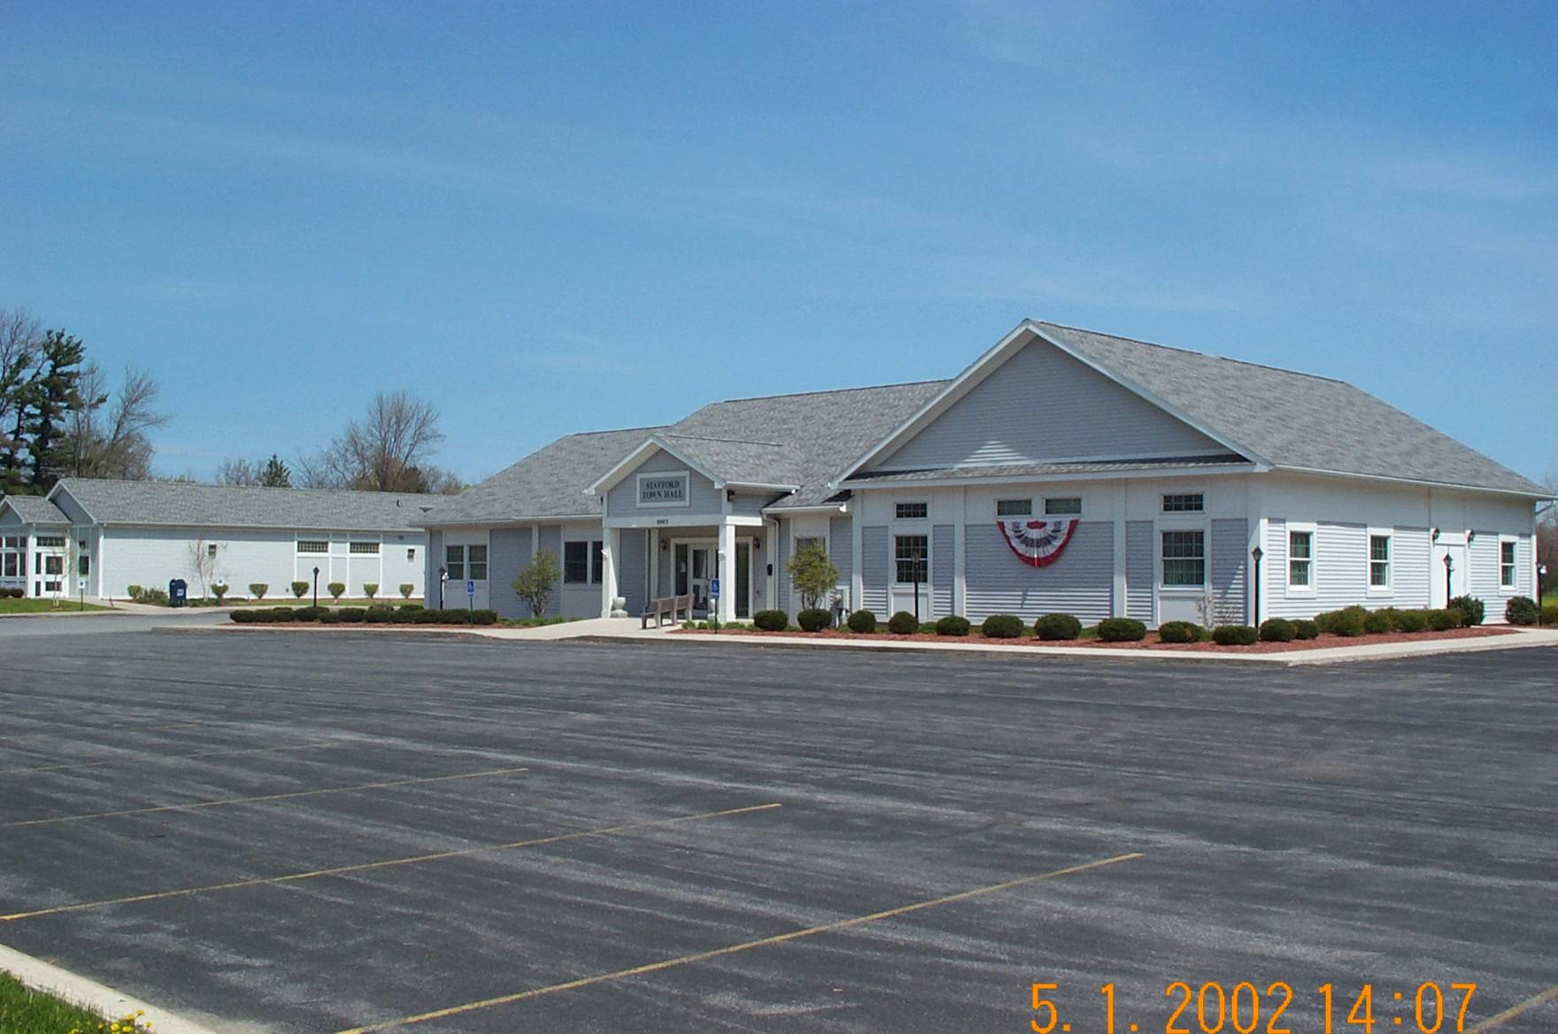  JAMES DUYSSEN  ROBERT PACER  TERRY YOUNG  Councilmen | STAFFORD, NEW YORK 14143  WWW.TOWNOFSTAFFORD.COM | Phone: [585] 344-1554  STEVEN BOLDT  Highway Superintendent  ROBERT MATTICE  ROBERT PENEPENT  Town Justice | Fax: [585] 345-0592  LORI FRONGETTA  Assessor  GENE SINCLAIR  Code Enforcement Officer  Zoning Enforcement Officer

ZONING BOARD OF APPEALS MEETING
JUNE 16, 2025

PRESENT: Mike Lathan, Chairman
Crista Boldt, Board Member
Tim Thomas, Board Member
Rob Chapman, Board Member
Sherry Roberts-Snell, Board Member
Barb Radley, Secretary

OTHERS PRESENT: Robert Clement, Gene Sinclair, Dave Carroll, Matt Fitgerald, T. White, Tony Prinz, Lori Prinz, Ian Shavitz, Cathy Worthington, Donna Voorhees, Andrew Darling and others not signed in.

Chairman Mike Lathan called the meeting to order at 7:20pm.

Sherry Roberts-Snell made a motion to approve May 19, 2025 meeting minutes as written, second by Rob Chapman and approved on a 5-0 vote.

Chairman Lathan asked the Code Enforcement Officer if Mr. Seaguss from last month had merged his properties as discussed or gotten any permits for a variance; Mr. Sinclair has not received any notice on either of these actions.

NEW BUSINESS

Chairman Lathan explained that this meeting is for the interpretation of the Notice of Violation against Carolina Eastern Crocker (CEC) and there will be no discussions as this is considered a Work Session.
At this time CEC’s attorney spoke of the violation of section 182.33B, he would like an interpretation as to whether this is the same as the case in 2020 and that the 100’ set back does not apply for an Ag business.

There was a permit granted at that time and then pulled because the building was not built. The side setback variance for the distance is in play because a residence is involved. Did they require a 100’ setback?

It was explained that we have had new counsel since that time and the interpretation may be different; we will have to look into that.

We will address the interpretation first before we grant a variance. The paperwork states storage of dry goods and this has been consistent. The Planning Board conditions to return excavated land to grass and a buffer are not at issue at the notice of violation.

Mr. Shavitz, the Prinz’s lawyer spoke about the 2020 decision for the 100’ setback, not from the building, there was a question at that time is this business a commercial or Ag business? It has been decided that it is an Ag business.
The set back is 40’ from the building to the lot line, the 30’ building was not built. A 200’ setback was needed for the variance, 40’ to 30’ was not used.

Chairman Lathan mentioned that the 100’ setbacks in the code are in question, it was in effect in 2020 also.

Mr. Shavitz reported that the two conditions by the Planning Board were not followed, one being that a “parking lot” in Prinz’s yard not to be allowed, this just stirs up more dust. A building on site is not in compliance. One- a foundation is built without a site plan and was approved, two-and addition is there without a permit.

Mr. Lathan reminded all that this is a meeting for interpretation of the violations of the code.

Board Member Tim Thomas then asked Mr. Sinclair about section 182.33; is this the only place where this issue is addressed? This is for not storing fertilizer. Yes.
It was also asked of Mr. Sinclair if he is able to enforce the Planning Board conditions; he is not sure. If there is a written complaint on zoning, he is able to act on that. Mr. Thomas also asked if we are able to characterize chemical storage and mixing facilities. The 2020 code identifies this.

Board member Crista Boldt asked if there is an application at this point, will they need to come in front of this board to pursue this variance and interpretation? Yes, first applications for $75.00 each need to be filled out and a Public Hearing will take place. The Public Hearing will be held 62 days from the time the application is granted.
Sherry Roberts-Snell made a motion to adjourn at 7:25pm, second by Rob Chapman and approved on a 5-0 vote.

Respectfully Submitted
Barbara Radley
Secretary

