TOWN OF STAFFORD
Est. March 24, 1820

P.O. BOX 52  ROBERT S. CLEMENT  Supervisor  RONALD PANEK  Deputy Supervisor  BARBARA RADLEY  Town Clerk | 8903 ROUTE 237  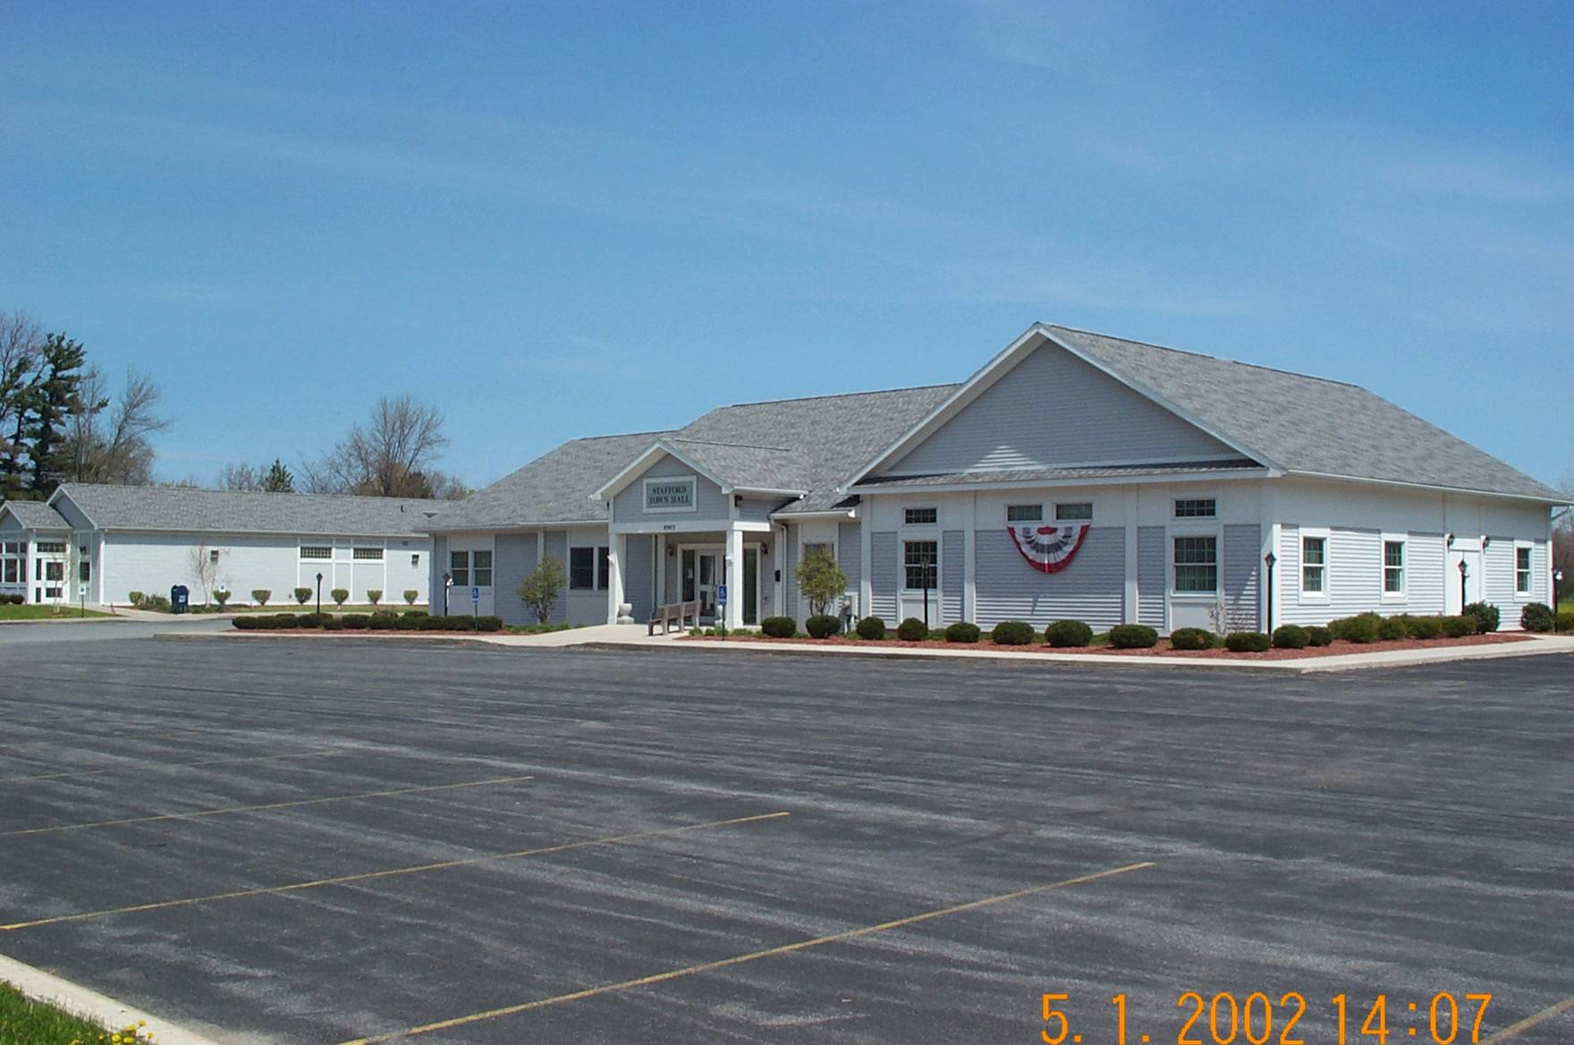  JAMES DUYSSEN  ROBERT PACER  TERRY YOUNG  Councilmen | STAFFORD, NEW YORK 14143  WWW.TOWNOFSTAFFORD.COM | Phone: [585] 344-1554  STEVEN BOLDT  Highway Superintendent  ROBERT MATTICE  ROBERT PENEPENT  Town Justice | Fax: [585] 345-0592  LORI FRONGETTA  Assessor  GENE SINCLAIR  Code Enforcement Officer  Zoning Enforcement Officer

STAFFORD PLANNING BOARD MEETING MINUTES
JUNE 25, 2025

PRESENT: Bill VanAlst, Chairman
Sharon Valyear-Gray, Board Member
Carol Queal, Board Member
Lindsay Yoder, Board Member
Richard Squires, Board Member
Barbara Radley, Secretary
ABSENT: Anita Taylor, Board Member
Lucas Torrey, Board Member

OTHERS PRESENT: Jeff Moore, Dave Royce, Stephen Worley, Janet Ward-Catalyze,
Bob Wood, Michelle Wood, Andrew Darling

Chairman VanAlst called the meeting to order at 7:02pm and reported that Anita Taylor was absent due to a funeral and Lucas Torrey was absent because of the birth of his baby girl.

Sharon Valyear-Gray made a motion to accept May 28, 2025 minutes, second by Richard Squires and approved on a 5-0-2 vote.

OLD BUSINESS:

The Solar Project of Genesee 5 & 6 were discussed. Janet Ward of the firm Catalyze spoke and reported that she has reviewed the Town Engineers’ comments of the Site Plan Review. The berm was questioned and it was reported that this will not be an elevated berm but a flat one and as the vegetation grows it will be maintained yearly; if there are dead plants, they will be replaced.
Catalyze has been reviewing the comments and will have the final summary prepared by July 4, 2025.
The easements were discussed; Genesee 5 will have the road for access to Genesee 6 and the survey is not completed at this time.
Janet has contacted the Fire Department and Genesee Soil and Water; she is not concerned about the Fire Trucks and the Soil and Water are fine with the seed mix. The Fire Trucks should be able to meet the requirements of a Utility Truck for the turnarounds; she will check to make sure this is the case.
For the Solar Law, the Planning Board will look at the Site Plan review and Zoning Code Section 182.27. The Town Board will look at the environmental aspects and Special Use Permits.

Janet Ward then asked how many copies of the plans we will need. It was decided that 16 copies of the half-size and 3 full-size copies of the plans for the Town Hall would be appropriate.

There was a question of a sub-station being on site, there is no need for this because of the size. Catalyze will connect to the transmission poles and at that point National Grid takes over.

The Site Plan Review Checklist was looked at; this will also be included in the report to be given on July 4, 2025. The fence will not be directly on the property line at Genesee 5; it will be 6 inches off the line. There will be no battery storage here and the Decommission Plan will be updated. There will be no need for utilities to have access to the projects, only the Fire Department and emergency services, the road is wide enough for them and they will focus more on landscaping.

There will be joint Public Hearing on the projects on July 28, 2025 at 7:00pm and 7:30pm for public input, then within 62 days a final decision needs to be made. The Town Board will make the final decision on the Special Use Permit.

NEW BUSINESS:

Heidelberg Materials from Main Rd. spoke about their plans for the demolition of the old material processing plant and building a new one in the lower “pit” of the site, where rock has already been excavated. This is necessary because of the age and outdated use of the present structure.
They were asked if they had a DEC permit for the mining operation as we do not have one on file, they will send one to the Town Clerk.
The question is whether they would need a Special Use Permit, Site Plan review or no zoning permit. Chairman VanAlst has reached out to the Town Attorney and has not received an opinion yet. As this information is relayed the Planning Board will act accordingly.

The main entrance will remain intact at its present location.

Lindsay Yoder will not be available for the July 28, 2025 Public Hearing.

Sharon Valyear-Gray made a motion to adjourn the meeting, second by Carol Queal and approved on a 5-0-2 vote.

Respectfully Submitted,
Barbara Radley
Secretary

