TOWN OF STAFFORD
Est. March 24, 1820

P.O. BOX 52  ROBERT S. CLEMENT  Supervisor  RONALD PANEK  Deputy Supervisor  BARBARA RADLEY  Town Clerk | 8903 ROUTE 237  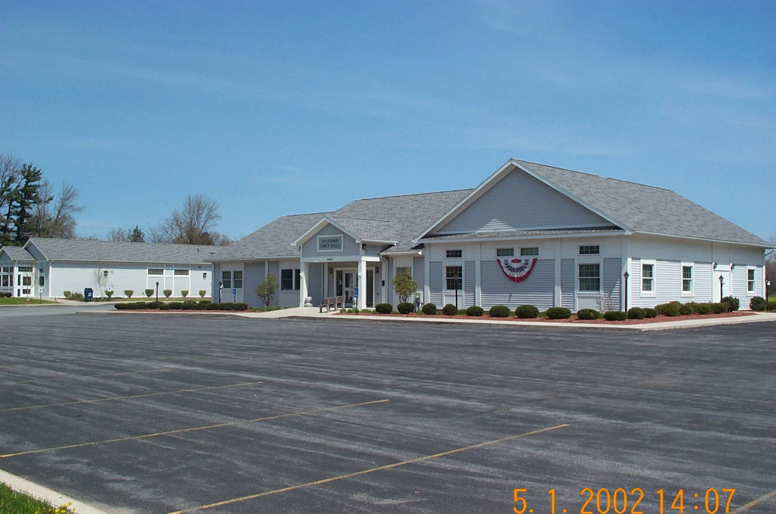  JAMES DUYSSEN  ROBERT PACER  EDMUND SCHRAMM  Councilmen | STAFFORD, NEW YORK 14143  WWW.TOWNOFSTAFFORD.COM | Phone: [585] 344-1554  STEVEN BOLDT  Highway Superintendent  ROBERT MATTICE  ROBERT PENEPENT  Town Justice | Fax: [585] 345-0592  LORI FRONGETTA  Assessor  GENE SINCLAIR  Code Enforcement Officer  Zoning Enforcement Officer

ZONING BOARD OF APPEALS MEETING AGENDA
JUNE 16, 2025

- Approval of Meeting Minutes from May 19, 2025

- Informational meeting in regard to the interpretation of the notice of violation issued by the Town of Stafford to Carolina Eastern Crocker

