TOWN OF STAFFORD
Est. March 24, 1820

P.O. BOX 52  ROBERT S. CLEMENT  Supervisor  RONALD PANEK  Deputy Supervisor  BARBARA RADLEY  Town Clerk | 8903 ROUTE 237  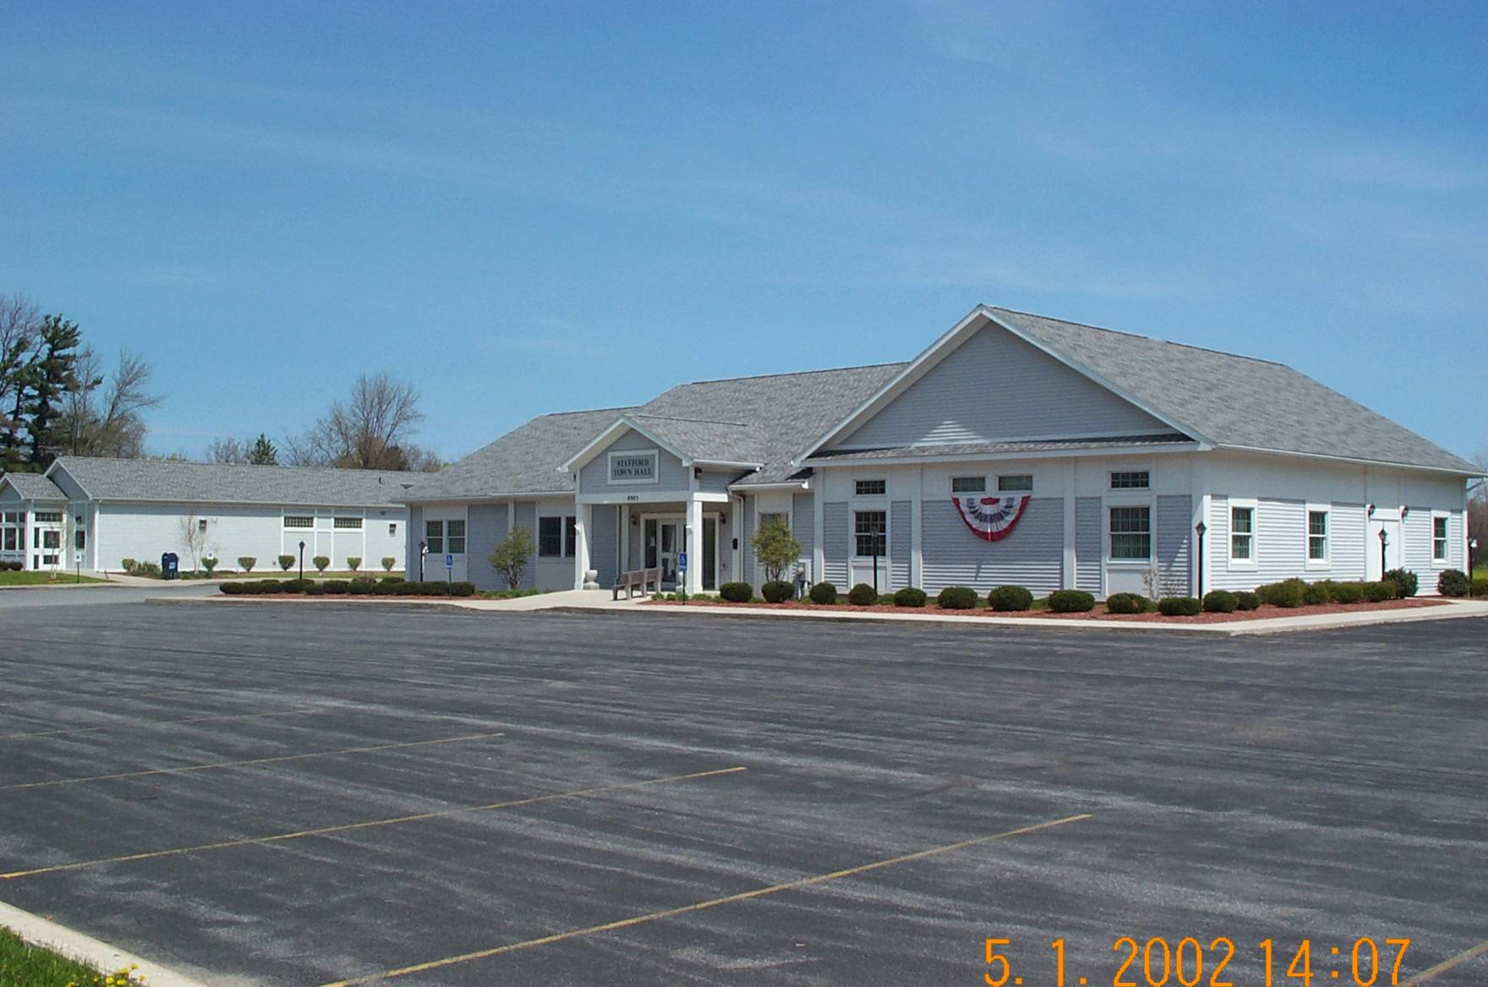  JAMES DUYSSEN  ROBERT PACER  TERRY YOUNG  Councilmen | STAFFORD, NEW YORK 14143  WWW.TOWNOFSTAFFORD.COM | Phone: [585] 344-1554  STEVEN BOLDT  Highway Superintendent  ROBERT MATTICE  ROBERT PENEPENT  Town Justice | Fax: [585] 345-0592  LORI FRONGETTA  Assessor  GENE SINCLAIR  Code Enforcement Officer  DONALD MULLEN  Zoning Enforcement Officer

Stafford Planning Board Meeting Minutes
May 28, 2025 DRAFT

PRESENT: Bill VanAlst, Chairman
Carol Queal, Board Member
Lucas Torrey, Alt. Board Member
Lyndsay Yoder, Board Member
Richard Squires, Board Member
Anita Taylor, Board Member
Barb Radley, Secretary
ABSENT: Sharon Valyear-Gray, Board Member
Paul Tenney, Board Member

OTHERS PRESENT: Tony Prinz, Dave Carroll, Bill Crocker, Andrew Darling.

Chairman VanAlst called the meeting of the Town of Stafford Planning Board to order at 7:03pm.

Carol Queal made a motion to accept the April 23, 2025 meeting minutes, second by Richard Squires and approved on a 6-0-2 vote.

Chaiman VanAlst mentioned that Sharon will not be attending this meeting, she is out of town today. Chairman VanAlst mentioned Paul Tenney’s absence and he has a resignation letter from Paul as well; therefore, Lucas Torrey will be a regular member tonight.

OLD BUSINESS:

The solar project Genesee 5 & 6 has an update: there will be a joint meeting with the Town Board on Wednesday, June 4, 2025 at 7:30pm to discuss the project in more detail.
Justin Steinbach from CPL, an engineer from that company will present information at the meeting. It was discussed who has updated plans, not everyone does.
Chairman VanAlst tried to confirm with LaBella, the engineers for the solar company about the plans but was unable to contact them. Chairman VanAlst will contact Catalyze for more details regarding landscape plans.

Chairman VanAlst asked that all members review the Site Plan Review Checklist before the June 4th meeting. Then the SEQR process will occur and the Town Board will name themselves as Lead Agent and the environmental review will be done by the Town Board. We will know more after Wednesday’s meeting.
There also will be a joint Public Hearing on the Environmental Review, Special Use Permit and Site Plan. CPL will have more information by the end of the week.

NEW BUSINESS

There is a change to the Employee Handbook, it does not apply to this board, Chairman VanAlst will provide all members with a copy of that.

Chairman VanAlst attended a Zoom Meeting with Camoin Associates, the Town Attorney, Ron Panek, Town Board Member, and the Supervisor. This was to update all on the Camoin Study and comment on the findings. It is reported, updated and under review with no final decision yet.
The Economic Impact of the solar project will be ready and when it is accepted, Chairman VanAlst will provide all members with a copy.

Board Member Paul Tenney has sent his resignation. A motion was made to accept with regret by Carol Queal, second by Lucas Torrey and approved on 6-0-2 vote. Chairman VanAlst will send a letter to Paul.

It was asked if Lucas Torrey would be interested in being a full member of the board; he accepted. Anita Taylor made a motion to recommend the appointment of Lucas Torrey as a full-time member of the Planning Board, second by Richard Squires and approved 6-0-2. Chairman VanAlst will send a letter to the Town Board for the resignation and recommends the appointment of Lucas Torrey as a full-time member and to advertise for an Alternate Member of the Planning Board.

The Genesee Finger Lakes Planning Council is holding a workshop on May 30, 2025 at GCC. Two members from the Planning Board as well as a few from the Zoning Board of Appeals will attend.

There was a Flood Plain informational meeting at County Building #2 on May 15th. Unfortunately, no one from this board was able to attend and it was mentioned in the Spring Newsletter.

A sample Local Law from the Town of Sweden was given to the members to review. This is in regard to public assembly; this may not have bearing on things of the past. We would have to modify this in order to fit in with the Town of Stafford and it will be forwarded to the Town Board for their review.

There was an amendment to the resolution for payment of the Planning and ZBA members taking training; we should all be set now.

The Flood Hazard Study is ongoing and the County’s Hazardous Materials Master Plan should be finalized soon.

Carol Queal made a motion to adjourn the meeting at 7:37pm, second by Richard Squires and approved 6-0-2.

Respectfully Submitted,
Barbara Radley
Secretary

