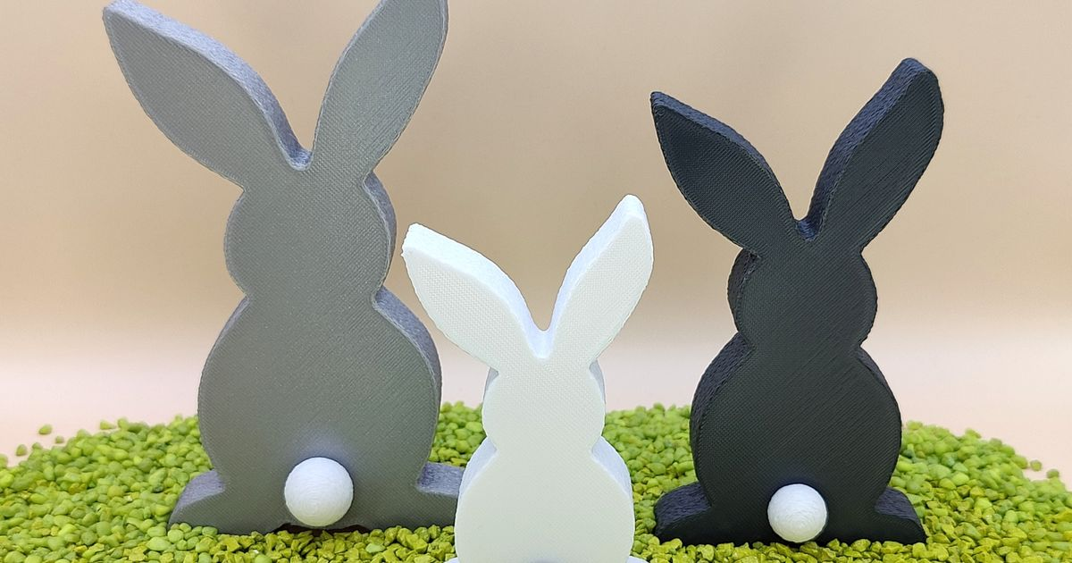

[This Photo](https://www.printables.com/cs/model/423598-easter-bunny) by Unknown Author is licensed under [CC BY-SA-NC](https://creativecommons.org/licenses/by-nc-sa/3.0/)

**THE TOWN OF STAFFORD OFFICES WILL BE CLOSED ON FRIDAY, APRIL 18, 2025.**

**HAPPY EASTER**